**Experiment No. 05**

**Aim:** To prepare Use Case and Activity diagram for Railway Management System

Use Case Diagram:

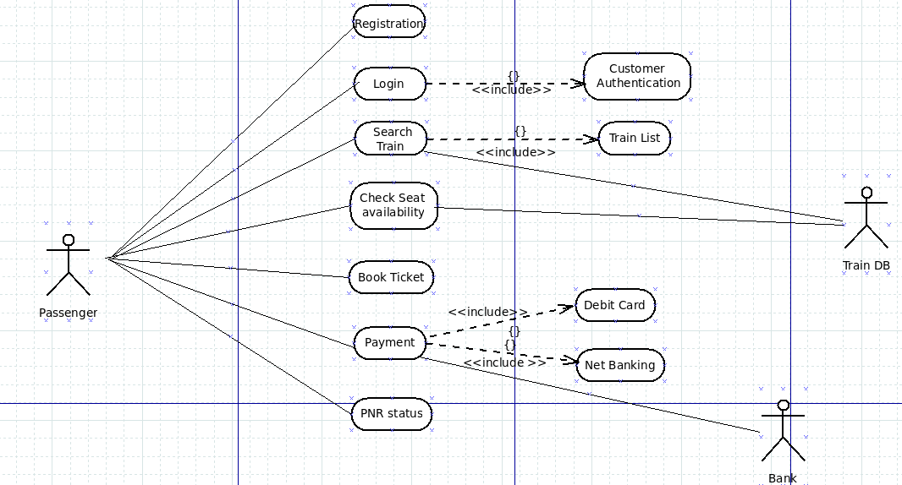

Activity Diagram:

